Introduction:
Purpose and Scope: The primary purpose of this emergency plan is to save lives and protect property in the event of an emergency. This plan is specifically intended to serve as a resource document to enhance emergency preparedness for residents and guests of the Forrest Groves Estates (FGE) community. Southwest Colorado, and the San Juan Mountains is an area at risk for a wide variety of emergency conditions. A description of many emergency situations is included in this plan with specific recommendations for preparedness and action.
Responsibility: FGE strongly encourages all landowners, residents, and guests of FGE to review this Plan and become familiar with its emergency contacts and recommendations. Although much of the Plan points to other organizations, emergency responders, and the services they provide, it is incumbent that everyone take personal responsibility for their own safety and protection of property, and as a community that values life, look out for the wellbeing of friends and neighbors in times of emergency.

Area Description:
Location and background: The FGE community is a privately owned residential subdivision, approximately twelve miles northeast of Durango, Colorado. The community is comprised of 51 lots, with most of these tracts having single family dwellings and associated structures and development. Overhead and underground electric service lines run throughout FGE. The FGE maintains community drinking water and wastewater system. Many properties use wood or propane systems for heating. Some propane tanks are underground with the majority being above ground. FGE maintains the gravel roads through neighborhood volunteers and paid commercial contractors for material maintenance, grading, snow plowing, and other related services.

Maps:
Detailed and dynamic maps of FGE and surrounds are available:
- GIS layered maps: https://gis.laplata.co.us/laplatajs/
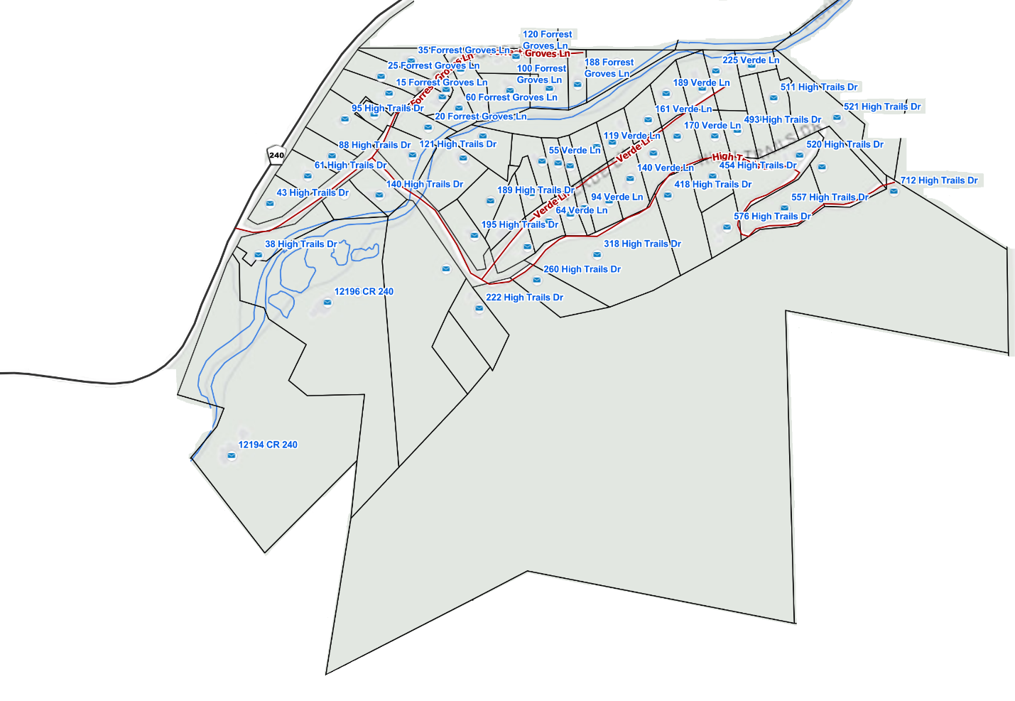

Evacuation Maps:
In the event of an emergency in the neighborhood, exit the neighborhood along Forrest Groves Rd to the 240. In the event that the bridge over the Florida River is damaged, emergency exit may be possible by fording the Florida River immediately downstream of the bridge. Caution! If you choose to ford the river, please consider that the river crossing is not maintained on a regular basis and that the water flow rate, water height and the river bottom change frequently.
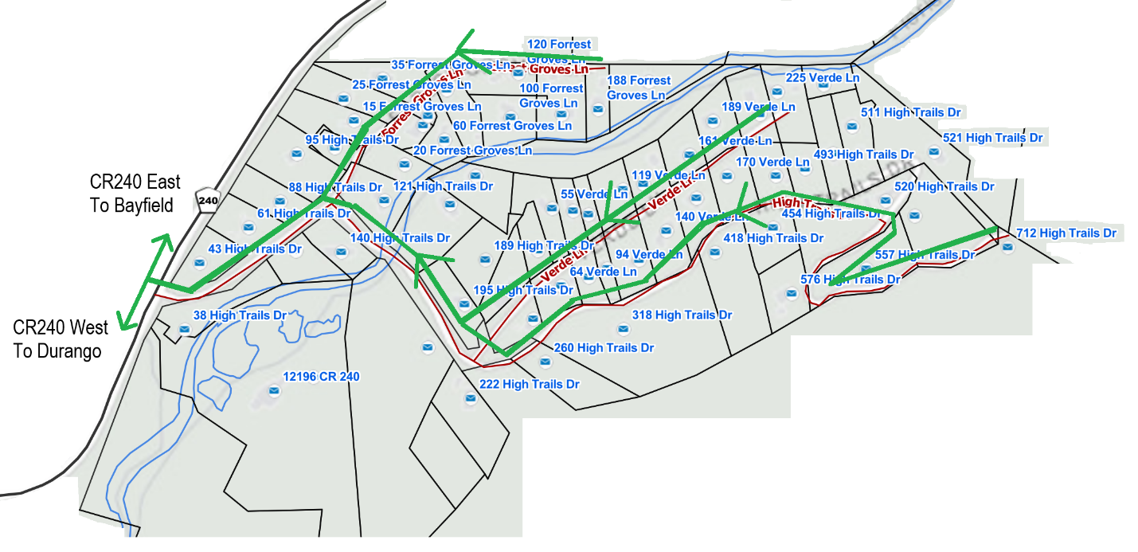

In the event of an emergency outside of the neighborhood (such as an evacuation because of a nearby forest fire), exit FGE and leave either by heading east or west on County Road 240 (“CR240”). There are multiple emergency routes from CR240; use the appropriate route depending on the location of the emergency, moving away from the emergency. These routes include:
- Evac West to Durango:
  - CR240 West to Durango (entirely paved)
  - CR240 West to CR234 South to 160 West to Durango (entirely paved)
  - CR240 East to CR501 South to 160 West to Durango (entirely paved)
  - CR240 West to CR245 South/East to CR502 West to CR228 West to CR234 South to 160 West to Durango (gravel)
  - CR240 West to CR245 South/East to 501 South to 160 East to Durango (gravel)
- Evac East to Bayfield:
  - CR240 East to CR501 South to Bayfield (entirely paved)
  - CR240 West to CR245 South/East to CR501
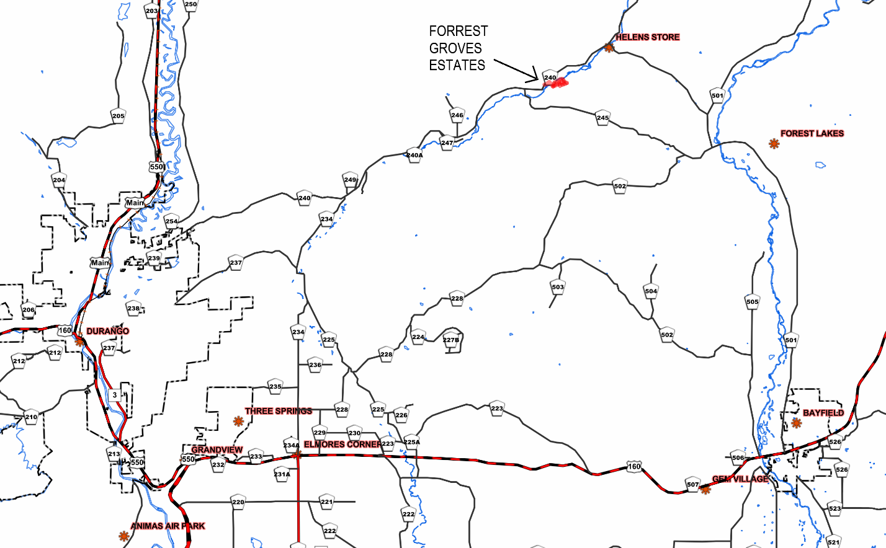
Medical Emergencies:
In the event of a medical emergency, first call 911 to activate emergency services.
Note: Cell phone calls made via WiFi may automatically provide an incorrect address to the 911 dispatcher. Be sure to provide your specific and accurate location to the 911 dispatcher.
Close Medical Services:
- Mercy Regional Medical Center
  - https://www.mountain.commonspirit.org/location/mercy-hospital
  - 1010 Three Springs Blvd., Durango, CO 81301
  - 970-247-4311
- Animas Urgent Care
  - 450 S. Camino Del Rio (Hwy 550), Durango, CO 81301
  - (970) 385-2388
- Durango Urgent Care
  - 2577 Main Avenue, Durango, CO 81301
  - (970) 247-8382
Emergency Contact Information:
Fire Map Tracking:
- Frontline Wildfire Defense: https://www.frontlinewildfire.com/colorado-wildfire-map/
- WatchDuty Wildfire Alert App: available at https://www.watchduty.org/

La Plata County:
- Code Red:
  - https://public.coderedweb.com/CNE/en-US/BFEA18547A8D
  - Get notified of an emergency by "reverse 911" on your cell phone.

- Emergency Contact Information: Continued

- Emergency Operations Center:
  - https://www.lpcgov.org/departments/emergency_management/index.php
  - 970-385-8700
  - 970-382-6275
  - OEMECC@lpcgov.org

Upper Pine Fire Protection District:
- https://www.upperpinefpd.org/
- 970-884-9508
- Station 3 (240 Corridor) @ 13407 CR 240
- Station 1 (Bayfield) 75 S. Clover Drive, Bayfield 970-884-4073
Colorado Parks and Wildlife Department:
- https://cpw.state.co.us/
- 151 East 16th Street, Durango, CO 81301
- 415 Turner Drive, Durango, CO 81301 970-247-0855
Colorado Department of Transportation Road Conditions:
- https://www.codot.gov/
- www.codot.gov/topcontent/trafficfooter
- Road conditions and travel information: COtrip.org
- Download the COtrip Planner app: bit.ly/COtripapp
- Sign up for project or travel alerts: bit.ly/COnewsalerts
- See scheduled construction lane closures: bit.ly/laneclosures
US Forest Service, San Juan National Forest Alerts and Warnings:
- https://www.fs.usda.gov/r02/sanjuan/alerts
- https://www.fs.usda.gov/list/sanjuan/alerts-notices/conditions?ss=110213&navtype=BROWSEBYSUBJECT&cid=STELPRDB5262330&navid=120000000000000&pnavid=null&position=Conditions*&ttype=list&pname=San%20Juan%20National%20Forest%20-%20Alerts%20amp;%20Closures
Emergency Evacuation Preparedness
What should I do BEFORE an emergency?
- Complete the Forrest Groves Estates Emergency Evacuation Checklist
- Enroll with Code Red to receive locally directed emergency notifications:
- Save the Emergency Contact Information above on your phone
- Join FGE community WhatsApp groups:
  - Download WhatsApp
  - Follow this link to join the Forrest Groves Community: https://chat.whatsapp.com/HPzDFSTbnrh46bpoU1Pw77
  - Join the Emergencies group, for emergency communications only
  - Join the General group, for general and non-emergency communications
- Prepare a “Go Bag” and place it near an exit in your house for quick evacuation. Go Bags should contain, at a minimum: glasses, contacts, and medications; important medical, legal, and financial documents; water; clothing. Suggestions for other Go Bag items can be found by running an internet search for “Go Bag contents”
What should I do DURING a stay-in place emergency (power outage, winter storms)?
- Maintain a water supply for at least three days
- Monitor the news and local radio stations, if possible
- Keep cell phones, laptops, flashlights, and battery packs charged, if possible
- Have alternative heat sources ready and know how to use them; check that carbon monoxide detectors are working
- Double-check that you are signed up for CodeRED and other emergency notification services
- Conserve heat by closing off unused rooms
- Monitor the FGE WhatsApp Emergencies group, which should issue an alert informing residents of an emergency situation.
- Please check on nearby neighbors

What should I do DURING an evacuation?
- Monitor the news and local radio stations
- Double-check that you are signed up for CodeRED and other emergency notification services
- Monitor the FGE WhatsApp Emergencies group, which should issue an alert informing residents of an emergency situation.
- Please check on nearby neighbors to ensure they are aware of the emergency
- Pack and go!

